Lab Experiments
SET -1
S. V. K. Sharon Surya
192324246

1. Set 1: Monthly Sales Data
Dataset: Monthly Sales
# Creating the dataset
Month <- c("January", "February", "March", "April", "May")
Sales <- c(15000, 18000, 22000, 20000, 23000)

sales_data <- data.frame(Month, Sales)

print(sales_data)

# Load library
library(ggplot2)

# Dataset
Month <- c("January", "February", "March", "April", "May")
Sales <- c(15000, 18000, 22000, 20000, 23000)

sales_data <- data.frame(
Month = factor(Month, levels = Month),
Sales = Sales
)

# Line Chart
ggplot(sales_data, aes(x = Month, y = Sales, group = 1)) +
geom_line(color = "blue", linewidth = 1.2) +
geom_point(color = "red", size = 3) +
labs(
title = "Monthly Sales",
x = "Month",
y = "Sales ($)"
) +
theme_minimal()# Line Chart
ggplot(sales_data, aes(x = Month, y = Sales, group = 1)) +
geom_line(color = "blue", linewidth = 1.2) +
geom_point(color = "red", size = 3) +
labs(
title = "Monthly Sales",
x = "Month",
y = "Sales ($)"
) +
theme_minimal()

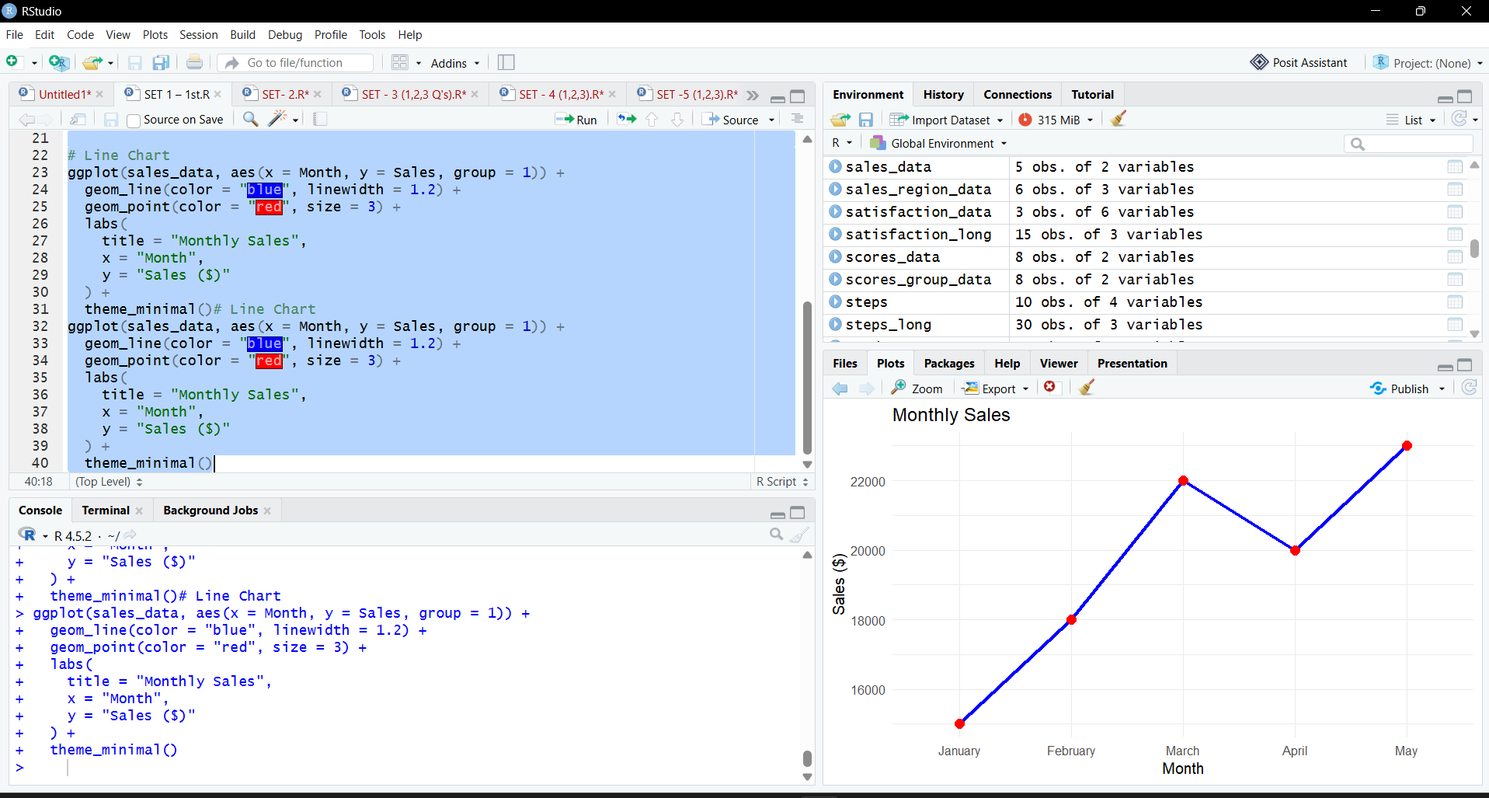

2.
library(ggplot2)

Product <- c("Product A",
"Product B",
"Product C",
"Product D",
"Product E")

Sales <- c(45000,
52000,
61000,
48000,
56000)

product_data <- data.frame(Product, Sales)

ggplot(product_data,
aes(x = Product,
y = Sales,
fill = Product)) +

geom_bar(stat = "identity") +

labs(
title = "Top Selling Products",
x = "Products",
y = "Sales ($)"
) +

theme_minimal()
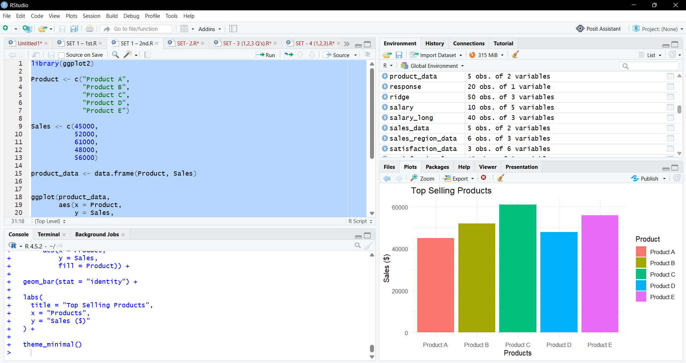

3.
library(ggplot2)

Advertising <- c(2000,
2500,
3000,
2800,
3500)

Sales <- c(15000,
18000,
22000,
20000,
23000)

scatter_data <- data.frame(
Advertising,
Sales
)

ggplot(scatter_data,
aes(x = Advertising,
y = Sales)) +

geom_point(
color = "blue",
size = 4
) +

labs(
title = "Advertising Budget vs Monthly Sales",
x = "Advertising Budget ($)",
y = "Monthly Sales ($)"
) +

theme_minimal()
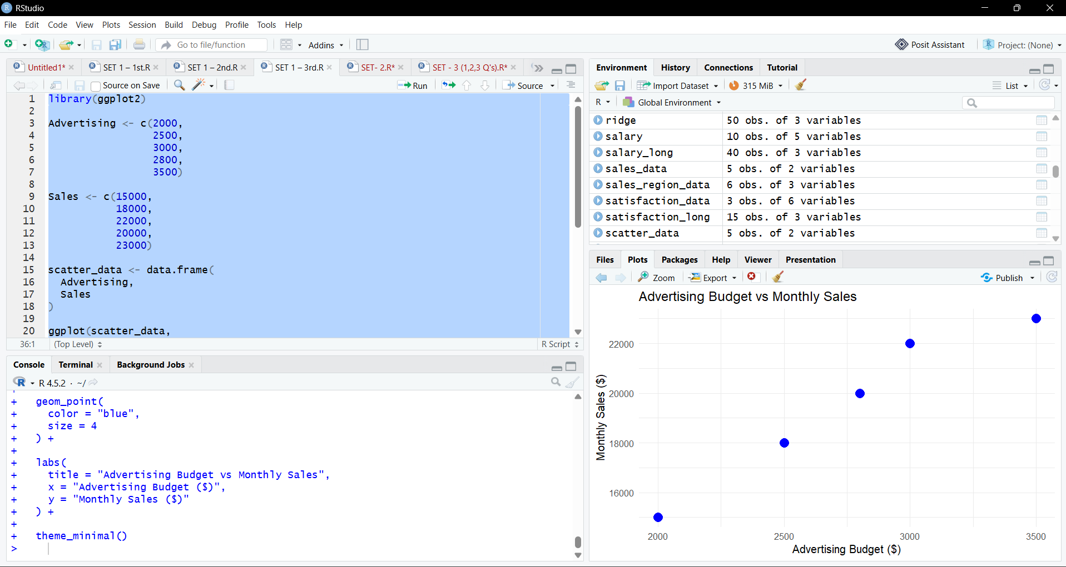

4.
